**TOPICS:** ERD Transformation **Allowed Time:** 90 Minutes

**Instructions: Total Marks:** 30

1. Gossips are not allowed.
2. Teacher assistants are for your help, so be nice with them. Respect them as they are teaching you. Raise your hands if you have some problem and need help from TA. Avoid calling them by raising your voice and disturbing the environment of Lab.
3. TA may deduct your marks for any kind of ill-discipline or misconduct from your side.
4. Evaluation will be considered final and you cannot debate for the marks. So, focus on performing the tasks when the time is given to you.
5. Paste the query as well as result table screenshot as a result of each task

****Note** :** After creating each table, use the DESCRIBE command to verify the table structure. This will display the column names, data types, and other details of the table. Take a screenshot of the Table creation Statement and output of Describe Statement and then paste into the document.

**Task 01: _________________________ ___________ (10 Marks)**

Create a database schema for a library management system based on the provided ER diagram.

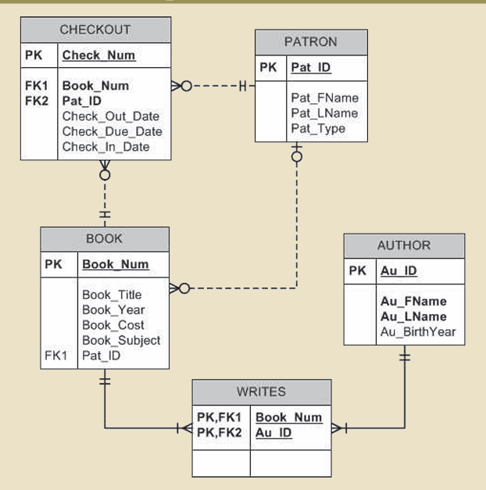

**Task 02: _________________________ ___________ (20 Marks)**

Create a database schema for a company named "LargeCo" based on the provided Entity-Relationship (ER) diagram.

